We have a parent template which has all the security groups and it outputs the security group IDs as well as exports them.  
  
  
  
While importing this template we have to give in 2 string parameters.  
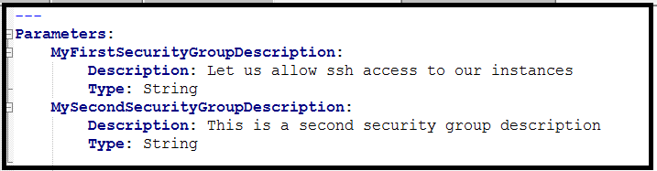  
  
This security group description is taken from ‘aws pseudo’ keywords or something. And the other description from a mapping.  
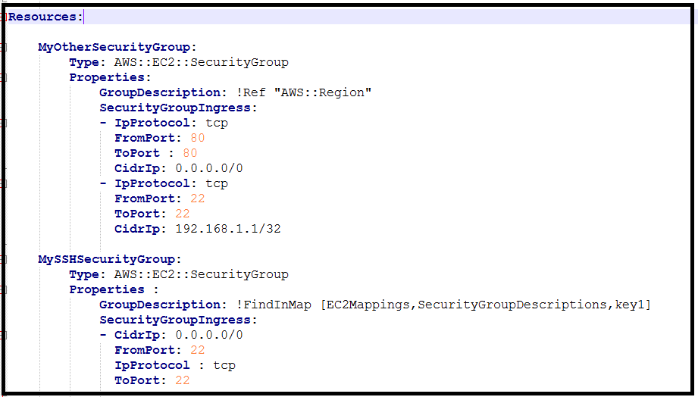  
Below are the mappings and a few outputs and exported values.  
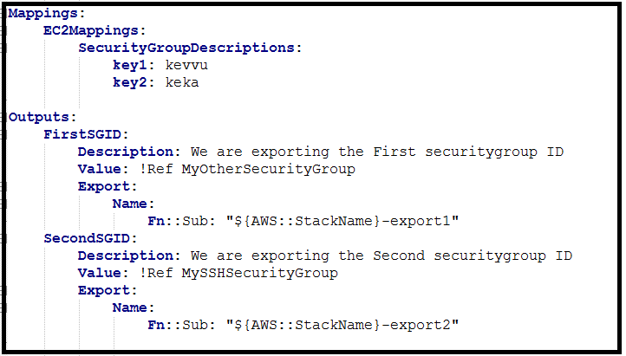  
  
  
Export : Note down the ‘Export name’.  
The outputs are the security group ids. Which will be used later for assigning them to ec2 instance via imports.  
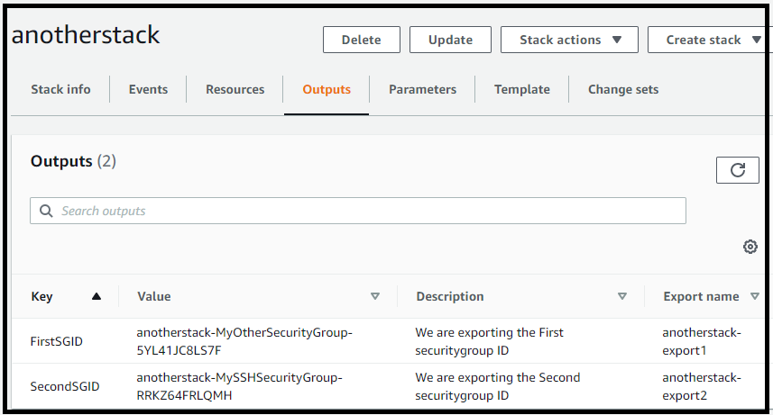  
  
  
  
  
-----  
  
  
  
Now create another stack. While importing we have to give the name of the parent stack.  
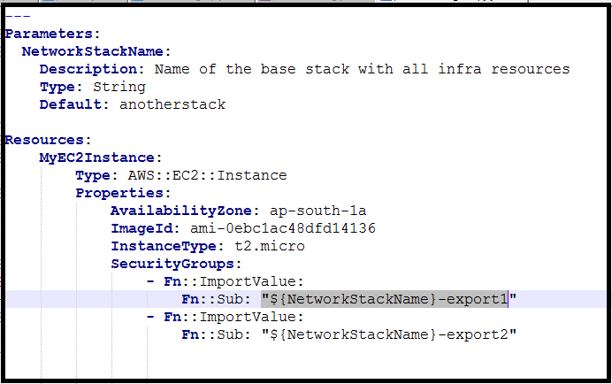  
  
EC2 instance is created with another instance.  
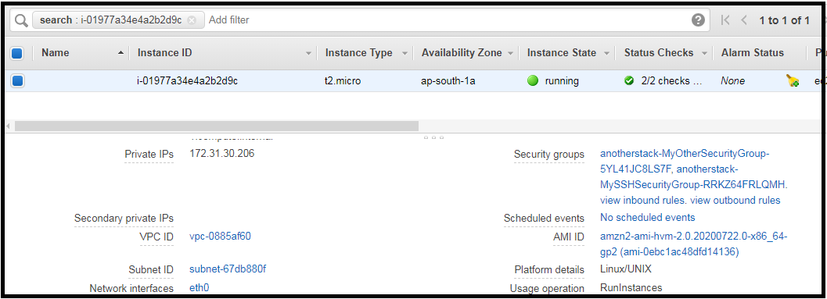

One of the security group will have a description taken from mapping and the other security group will have a description taken from aws pseudo names called as AWS::REGION.  
